CE301 Individual Capstone Project dp19963

**Goals until the next meeting:**

Until my third meeting with my supervisor I did the following, I made a front page where you have to login to the software using the given values in my database.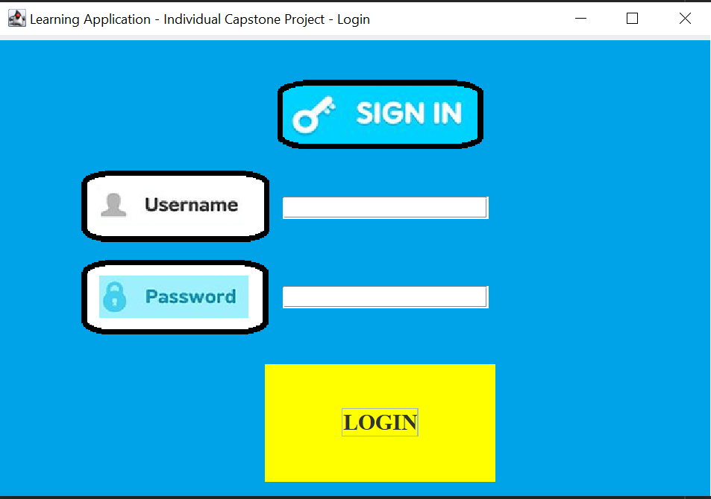

Username will be shown whereas password will not be visible. Also entering the wrong password you’ll be told in a small text “Wrong username or password!”.

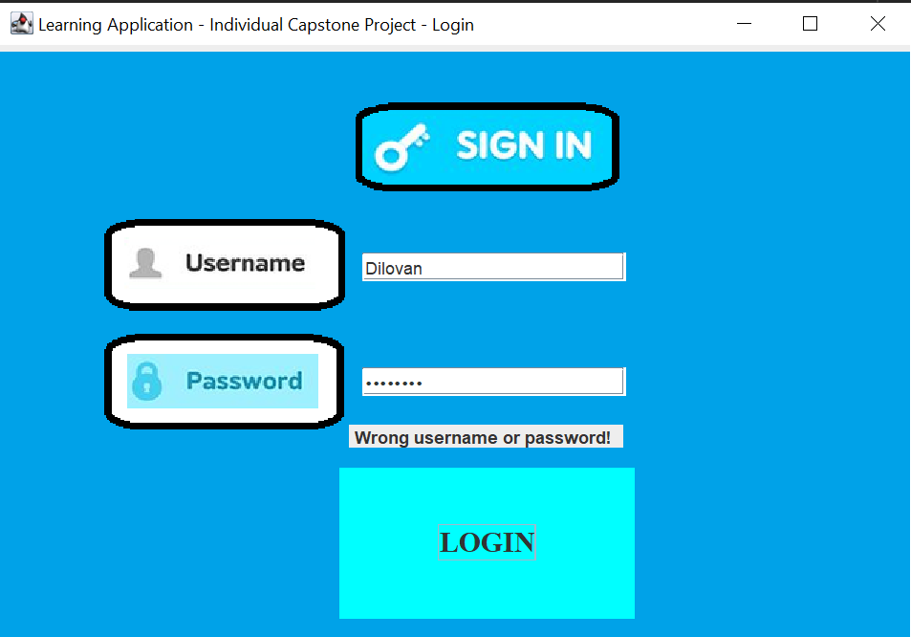

Keys pressed and end results of what you typed when attempting to login will be shown in the console log.

